Do High-Performance Image-to-Image Translation Networks Enable the Discovery of Radiomic Features? Application to MRI Synthesis from Ultrasound in Prostate Cancer

**High Resolution Figures and Tables**

**Table.** Training parameters. D: Discriminator, G: Generator, MSE: Mean Squared Error, MAE: Mean Absolute Error, LSE: Least Squared Error.

|  |  |  |  |  |  |
| --- | --- | --- | --- | --- | --- |
| **Parameters** | **2D-Pix2Pix** | **2D-CycleGAN** | **3D-CycleGAN** | **3D-AutoEncoder** | **3D-UNET** |
| **GPU** | RTX 3090 24 GB | RTX 4090 24 GB | RTX 3090 24 GB | RTX 4090 24 GB | RTX 4090 24 GB |
| **Framework** | TensorFlow 2 | TensorFlow 2 | TensorFlow 2 | TensorFlow 2 | TensorFlow 2 |
| **Batch Size** | 1 | 1 | 1 | 1 | 1 |
| **Epoch** | 1000 | 1000 | 1000 | 1000 | 1000 |
| **Learning rate** | D = 0.000001 G = 0.00001 | D X = 0.0001 D Y = 0.0001  G G = 0.00001 G F = 0.00001 | D = 0.000001 G = 0.0000001 | 0.00001 | 0.00001 |
| **Generative loss functions** | L1 Loss (MAE) | Adversarial Loss (MSE) + Cycle Loss | Adversarial Loss (LSE) + Cycle Loss | MSE | MSE |
| **Discriminator loss functions** | Sigmoid Cross-Entropy Loss | Cycle-Consistency Loss | Cycle-Consistency Loss | MSE | MSE |

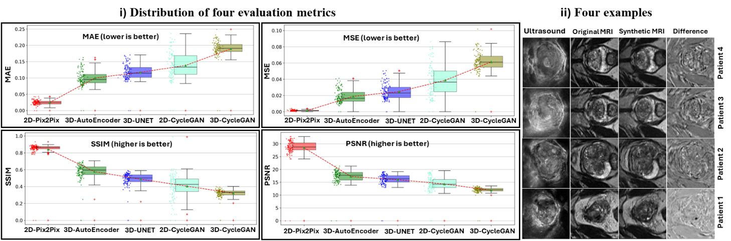

**Figure. (i)** A distribution of four quantitative evaluation metrics: MAE, MSE, SSIM, and PSNR for 2D-Pix2Pix, 2D-CycleGAN, 3D-CycleGAN, 3D-AutoEncoder, and 3D-UNET in synthesizing MRI images from Ultrasound images, **(ii)** four examples of synthetic MRI images provided by 2D-Pix2Pix. Rows show Ultrasound, Original MRI, Synthetic MRI, difference between original and synthetic MRI images. Columns show different patients. All synthetic images had SSIMs>0.85. MAE: Mean Absolute Error, MSE: Mean Square Error, SSIM: Structural Similarity Index, PSNR: Peak Signal to Noise Ratio.

**Figure.** Different Radiomic feature (RF) groups provided by RF Analysis. i) Group 1 showed 18 low-level RFs successfully discovered by synthetic MRI images generated through majority of algorithms, ii) Group 2 showed 75 low-level RFs were successfully discovered from synthetic MRI images generated by 2D-Pix2Pix, and iii) Group 3 showed synthetic MRI images generated by the current generative networks couldn’t discovered 93 low-level RFs.

**Table.** Qualitative analysis of synthetic MRI by 5 medical doctors (D).

|  |  |  |  |  |  |
| --- | --- | --- | --- | --- | --- |
| **Questions (Q), Scoring system: 0= zero, 1= low, 2=intermediate, 3=high, 4=very high** | **D 1** | **D 2** | **D 3** | **D 4** | **D 5** |
| Q1: What is your medical specialty and how many years of experience do you have in interpreting MRI and ultrasound images? (years) | >5 | >6 | >5 | >5 | >5 |
| Q2: How many doctors could discriminate the synthetic MRI from the original MRI properly? (15 external testing images existed) | 15 | 15 | 15 | 15 | 15 |
| Q3: After specifying synthetic and original MRI for you, how would you rate the overall quality of synthetic MRI images compared to original MRI? | 1 | 2 | 1 | 1 | 1 |
| Q4: Are there any noticeable artifacts or inaccuracies in the synthetic MRI images? | 4 | 2 | 4 | 4 | 3 |
| Q5: How confident are you in making a diagnosis based on synthetic MRI images versus original MRI? | 1 | 1 | 1 | 1 | 1 |
| Q6: Do synthetic MRI images offer any additional diagnostic information compared to the original MRI images? How much? | 0 | 0 | 0 | 0 | 0 |
| Q7: Do synthetic MRI images offer any additional diagnostic information compared to the original Ultrasound images? How much? | 2 | 2 | 3 | 2 | 3 |
| Q8: How do you assess the resolution and contrast of the synthetic MRI images, compared to original MRI images? | 1 | 2 | 1 | 2 | 2 |
| Q9: In your opinion, how much are the potential clinical benefits of using synthetic MRI images? | 4 | 3 | 3 | 4 | 3 |
| Q10: Would you support the integration of synthetic MRI technology into regular clinical practice? How much? | 4 | 4 | 4 | 4 | 4 |